بسم الله الرحمن الرحيم

King Saud University
College of Engineering
Civil Engineering Department

SE 365: “Principles of Remote Sensing & Image Interpretation”
1444H 1st Semester

Homework #2 Solutions

Q1: The IR portion of the spectrum has 2 parts, the reflective (near & mid) & the emissive (thermal); can you take photographs in these wavelength ranges? Why?
Answer;
Photographic films are sensitive to light from 0.3 μm to 0.9 μm in wavelength covering part of the UV, visible, & part of the NIR. Therefore, only the part between 0.7 to 0.9 μm can be photographed.

Q2: Where is the light are coming from that illuminates the dark side of the moon?
Answer;
That's called Earthshine. Its sunlight reflecting off the Earth and illuminating the lunar night, exactly the way moonlight is sunlight reflecting off the moon to illuminate our night.
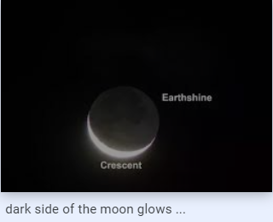

Q3: What would be the best way to map deciduous & coniferous trees in a forest in the summer time? Why? Use the reflectance curve to illustrate your answer?
Answer;
Spectral response can be quite variable, even for the same target type, & can also vary with time & location. Therefore the best way to map deciduous & coniferous trees in a forest in the summer time is by using the near-IR portion of the spectrum because deciduous trees, as we can see from the diagram, reflect much more energy in this portion of the spectrum than coniferous trees. And as you can see from the two photos, we cannot discriminate easily between them in the first photo taken in the normal B&W photo; never the less, it is much easier to discriminate between deciduous, lighter color, & coniferous trees, darker color, in the second photo taken in the B&W IR photo.

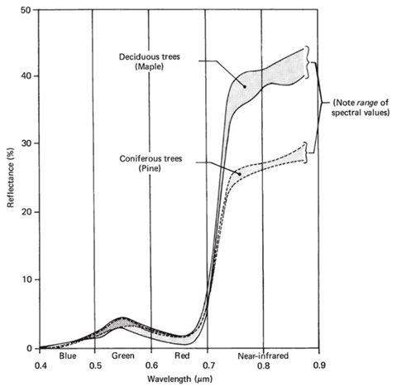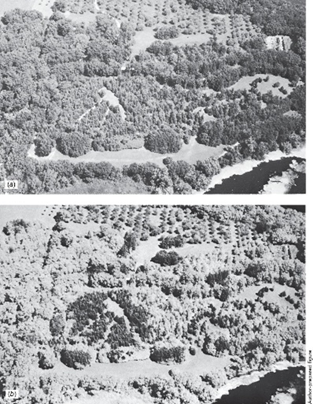

Q4: Explain briefly the reference data term & its role in R.S.
Answer;
Rarely, if ever, is RS employed without the use of some form of reference data, or more often used term ground troth. Acquisition of reference data involves collecting measurements or observations about the objects, area, or phenomena that are being remotely sensed. These data can take on any of a number of different forms & may be derived from a number of sources. The identity & location of some of land cover types are known through a combination of fieldwork, analysis of aerial photography, maps personal experience, etc. Reference data can be very expensive & time consuming to collect properly. They can consist of either time-critical &/or time-stable measurements.
Reference data might be used to serve any or all of the following purposes:
1. To aid in the analysis & interpretation of RS data.
2. To verify information extracted from RS data.
3. To calibrate a sensor after they were launched.

